ORGANIZATIONAL APPROACHES TO BRAND IDENTITY ON SOCIAL MEDIA: COMPARING BRAND FACEBOOK PAGES AND WEB SITES.

Adam Peruta
Integrated Marketing Communications
R.H. Park School of Communications
Ithaca College
Ithaca, NY
aperuta@ithaca.edu

William Ryan
Communication Management and Design
R.H. Park School of Communications
Ithaca College
Ithaca, NY
wryan@ithaca.edu

Gregory Acquavella
Communications
R.H. Park School of Communications
Ithaca College
Ithaca, NY
gacquav1@ithaca.edu

ABSTRACT
Corporate branding online is currently at a crossroads. Branding involves using symbols, names, or visual designs to communicate the identity and tone of a corporation, but, with the arrival of social media, corporations need to rethink and restructure their branding efforts. The structure of social media sites changes the way brand values and philosophies are communicated to the consumer. Sites, such as Facebook, provide a way for corporations to directly interact with and respond to their consumers. Through an exploratory content analysis, this study looks at 40 of the top brands listed on Interbrand’s 100 Best Global Brands of 2011 list and compares the brands’ Web sites and Facebook pages. The study documents that while these brands are adding content to their Facebook, they are not utilizing or leveraging their brand identity to interact with consumers on these sites. This finding presents a huge opportunity for brands looking to extend their exposure to consumers through social media.

KEYWORDS
social media, branding, Facebook, Websites

ORGANIZATIONAL APPROACHES TO BRAND IDENTITY ON SOCIAL MEDIA: COMPARING BRAND FACEBOOK PAGES AND WEB SITES.

INTRODUCTION
Social media are changing the way corporations are structuring their branding efforts. Because people are spending an increasing amount of time using social media, corporations are expanding their branding initiatives to extend their presence on these new platforms to reach their audiences. The most popular social media Web site, Facebook, has over 800 million users worldwide. There has been little research examining branding practices in regard to corporate Facebook pages. The purpose of this exploratory study was to conduct a systematic content analysis of a sample of branded Facebook pages and brand Web sites. Forty brands were selected from Interbrand’s annual list of 100 Best Global Brands. Data were collected using a standardized coding form.

Social media has enabled organizations to do things that were previously not thought possible. Organizations can directly interact and respond to customers as well as advertise their product or service through multiple new mediums. According to Scott, “social media provide the way people share ideas, content, thoughts and relationships online.”¹ Facebook, Twitter and YouTube are all examples of social media Web sites. Social networking Web sites—a subset of social media—utilize two-way communication. Boyd and Ellison identify three characteristics of social networking sites: users create a profile within a system, users have a list of other users they have a connection to, and users can examine and navigate their list of connections.² This online network described by Boyd and Ellison supports the notion of online community, which is an important aspect of social media.

Facebook is one of the largest online communities. The authors selected to analyze Facebook because it is the most visited U.S. Web site in America.³ Every company has the ability to create a Facebook page for their organization as many have already done. The Nielsen Social Media Report found that 53% of social media users follow a brand.⁴ Within the next five years, Booz & Company argue that the market for social commerce will greatly expand, making Facebook brand pages important for organizations to create and maintain.⁵ With this expanding social marketplace, researchers in both brand design and social media need to understand how organizations are utilizing this new market. New social media platforms, such as Facebook, make it easier for brands to create and manage brand communities.

Interbrand—the world’s largest brand consultancy—defines the term brand, as a “living business asset.”⁶ Jez Frampton, the Global Chief Executive at Interbrand discusses how brands need to be able to adapt and stay ahead of the changes that happen around them. Frampton identified social media as one of those changes brands need to adapt to and leverage. If not, a great opportunity will be missed. When analyzing the brand’s Web site and Facebook page, numerous branding concepts should be examined. Even though there is a great amount of literature on the intangible aspects of a brand, such as brand personality, the authors chose not to examine any intangible concepts. Even though these aspects are sometimes easy to identity, a valid and reliable scale that measures brand personality has not yet been created.⁷ In this study, the authors focus on multiple visual components that help create and maintain brand identity. According to Aaker and Joachimsthaler, brand identity is “a vision of how that brand should be perceived by its target audience.”⁸ Keller argues, “customer-based brand equity occurs when the consumer has a high level of awareness and familiarity with the brand and holds some strong, favorable, and unique brand associations in memory.”⁹ Part of this branding process involves the use of branding elements that assist consumers with their identification of the brand. Furthermore, these elements should help trigger positive associations. Keller lists the “main brand elements” as “names, logos, symbols, characters, slogans, jingles, and packages.”¹⁰

Social media platforms enable brands to create brand communities, which are another touch point to which the company’s branding strategy must be applied. Muniz and O’Guinn define a brand community as “a specialized, non-geographically bound community, based on a structured set of social relationships.”¹¹ Today, organizations are using Facebook to build virtual brand communities. When an individual ‘likes’ a certain Facebook page, they become a member of that brand’s community. Facebook provides consumers with a way to become involved in numerous brand communities simultaneously.

To further explore how corporations are using their branding on Facebook and to what degree it is consistent with their Web site, this study will answer the following questions:

RQ1: Are brands using brand identity elements on their Facebook pages, and to what extent?
RQ2: Are the same brand identity elements present on both the brand Facebook page and Web site?
RQ3: What is the relationship between the level of branding on the Facebook page and Facebook likes? How does that compare to the relationship of content posting to the Facebook page and the number of likes?
RQ4: Is there a relationship between the Interbrand ranking and the Facebook page branding and usage?
METHOD
For the content analysis, 40 brands in total were selected at random from Interbrand’s annual list of 100 Best Global Brands. The brands listed in Interbrand’s report are ranked according to the ongoing investment and management of the brand as a business asset. The Interbrand methodology takes into account all the many ways in which a brand touches and benefits its organization—from attracting and retaining talent to delivering on customer expectations. The three aspects contributing to the Interbrand assessment are: the financial performance of the branded products or services, the role of brand in the purchase decision process, and the strength of the brand. The report contained brands from 18 business sectors. The sample chosen included brands from 14 out of the 18 sectors including: alcohol, apparel, automotive, business services, computer software, diversified, electronics, financial services, fmcg, luxury, media, restaurants, sporting goods, and transportation. Table 1 lists the selected brands with the associated sector in descending order by Interbrand ranking.

Table 1. Brands used in the content analysis of Facebook pages and Web sites by Interbrand ranking.

Interbrand Ranking | Brand | Sector
2 | IBM | Business Services
3 | Microsoft | Computer Software
5 | GE | Diversified
6 | McDonald’s | Restaurants
7 | Intel | Electronics
9 | Disney | Media
10 | HP | Electronics
12 | Mercedes Benz | Automotive
13 | Cisco | Business Services
15 | BMW | Automotive
23 | American Express | Financial Services
25 | Nike | Sporting Goods
26 | Amazon.com | Internet Services
27 | UPS | Transportation
32 | HSBC | Financial Services
34 | Sony | Electronics
37 | Thompson Reuters | Media
38 | Goldman Sachs | Financial Services
41 | Philips | Electronics
44 | Zara | Apparel
45 | Accenture | Business Services
46 | Siemens | Diversified
47 | Volkswagon | Automotive
48 | Nintendo | Electronics
52 | Danone | FMCG
53 | AXA | Financial Services
58 | MTV | Media
68 | Santander | Financial Services
70 | Cartier | Luxury
82 | Credit Suisse | Financial Services
84 | Gap | Apparel
85 | 3M | Diversified
86 | Corona | Alcohol
87 | Nivea | FMCG
89 | Smirnoff | Alcohol
90 | Nissan | Automotive
91 | Heineken | Alcohol
93 | Armani | Luxury
99 | Ferrari | Automotive
100 | Harley Davidson | Automotive

A Facebook and Web site content analysis rating form was developed by the authors, pretested, revised and used to rate each of the 40 brand Facebook pages and their respective brand Web site homepages. The first section of the form consisted of Web site characteristics answered by indicating either yes or no and then noting the total number of items if applicable. The second section consisted of nine Likert-type items designed to capture the extent to which brand identity elements are present. These items used a five-point response scale (1=not used prominently, 5=used prominently). In the case a brand identity element was noted as “no,” a 0 was used in the analysis to separate it from the five-point scale. The same analysis form was used to evaluate both the brand’s Facebook page and the Web site homepage. Facebook elements were assessed on all pages within the brand’s Facebook domain. Web site elements were only assessed from the brand’s homepage.

Table 2. Rating form used to assess characteristics present on the 40 brand Facebook pages and Web sites.

Web site characteristics | Y/N, n | Rating | Count
Facebook likes |  | --
Facebook pages |  | --
Facebook timeline |  | -- | --
Encouraged to like |  | -- | --
Required to like |  | -- | --
Links |  | --
Link for product information |  | --
Link for social media |  | --
Advergames |  | --
Commercials |  | --
Total videos |  | --
Advertisements |  | --
Photos |  | --
Polling app |  | -- | --
Other apps |  | --
Brand Identity Elements
Color |  |  | --
Tagline/slogan |  |  | --
Visual of product/package |  |  | --
Logo or product symbol |  |  | --
Promotional characters |  |  | --
Non-promotional characters |  |  | --
Mascot/trade figure |  |  | --
Movement |  |  | --
Interactivity |  |  | --

For the nine questions rated on the Likert scale, each brand identity element was measured by the amount of screen real estate it covered and/or the number of times the element appeared. For example, a rating of 1 for non-promotional characters (photographs, images, illustrations of characters not paid to endorse the product or service) would mean that it only appeared once and accounted for less than 10% of the controlled design area. A rating of 5 for non-promotional characters would mean that the visual of the characters was the most dominant element and/or appeared multiple times, taking up more than 60% of the controlled design area. Figure 1 shows the Facebook page for Volkswagon, which received a rating of 1 for non-promotional characters, and the Facebook page for Nivea USA, which received a rating of 5.

Figure 1. The Facebook pages for Volkswagon and Nivea USA.

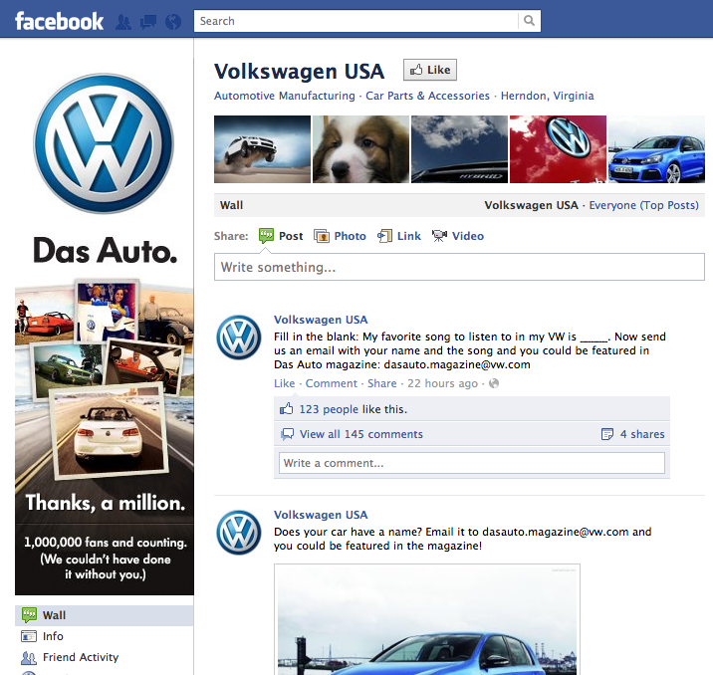 | 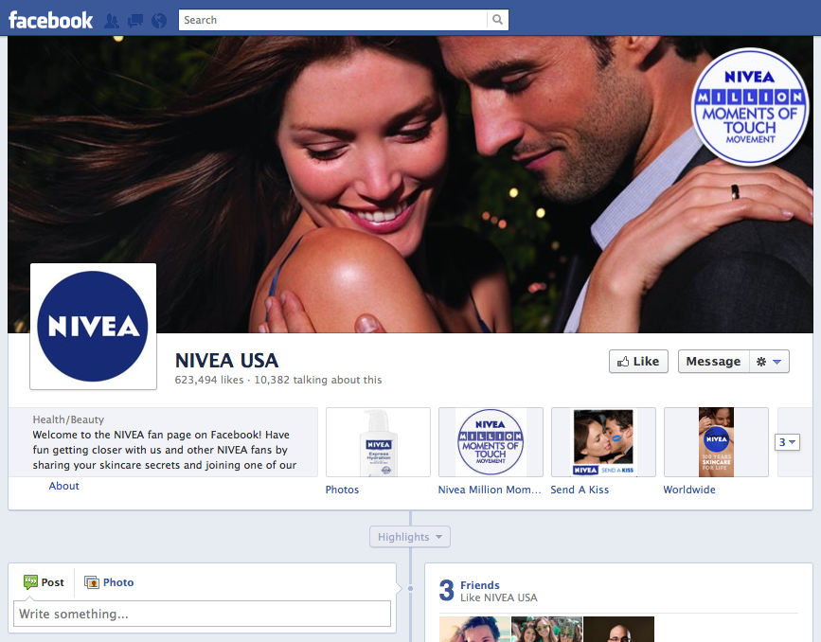
http://www.facebook.com/vw | http://www.facebook.com/niveausa

Figure 2 shows the Web site for HSBC, which received a rating of 1 for non-promotional characters, and the Web site for Siemens Healthcare, which received a rating of 5.

Figure 2. Web site homepages for HSBC and Siemens Healthcare.

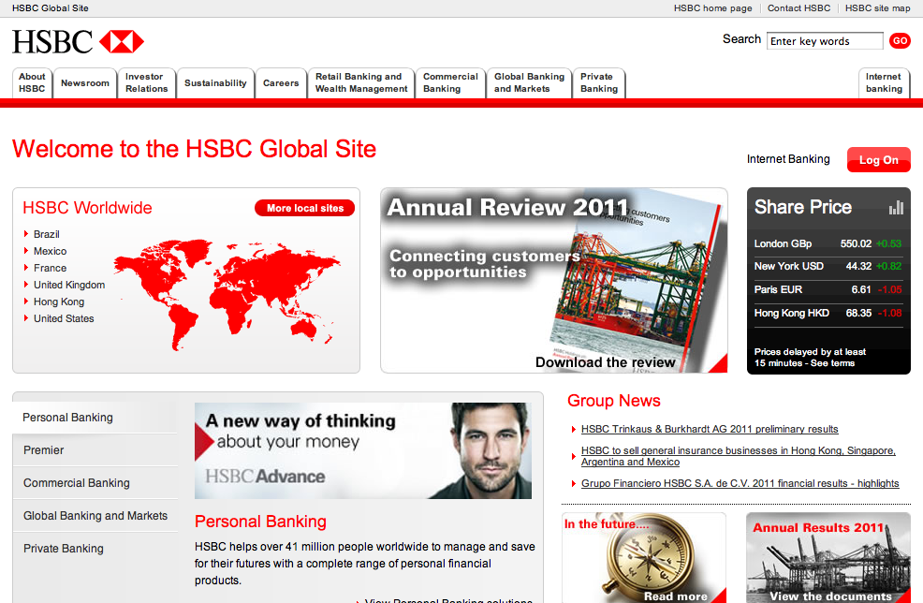 | 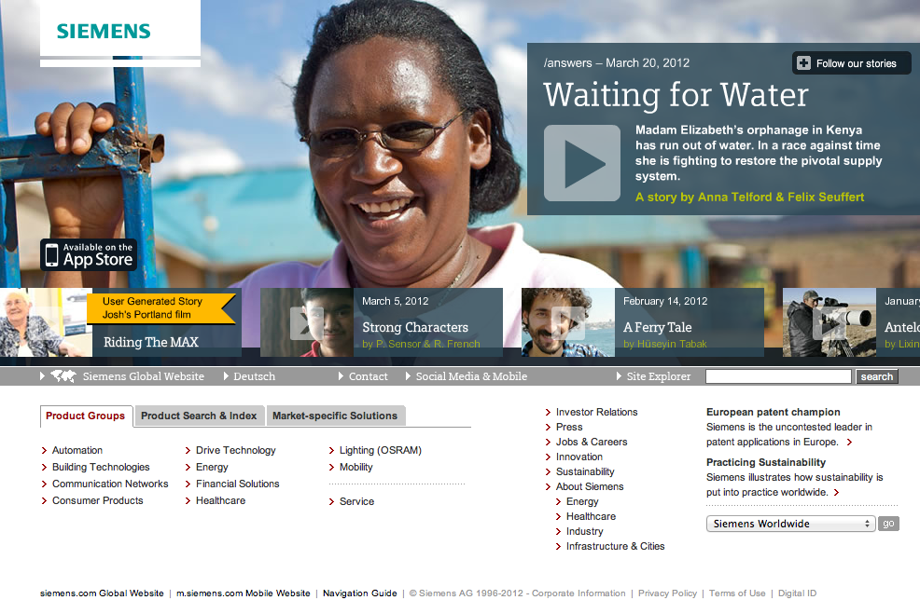
http://www.hsbc.com/1/2 | http://www.siemens.com

One final factor the authors needed to integrate into the analysis was that 16 of the 40 brands the authors analyzed were using Facebook’s new timeline format; the rest were not. Timeline was implemented as the official page format for brands on Facebook as of March 30, 2012. The coding took place from March 12, 2012 to March 21, 2012. This meant that analysis took place during a period of great change in Facebook page design.

RELIABILITY DATA
To assess inter-rater reliability, four brands not part of the sample were coded by two independent raters as part of a pilot study using the coding sheet (table 2) to determine percentage agreement on the form. In addition, a 40% subset (or 16) of the 40 brands in the main study overlapped to confirm this reliability data. The data was broken down into nominal, ordinal, and ratio components. Nominal data included all yes and no questions about the presence of brand elements, interactivity, movements, sound, encouragement/requirement to like the brand, a polling system, as well as links, images, or videos. Ordinal data included the 5-point brand items; a sixth point—a score of 0—was added when the item was not present. Ratio data included the numbers of links, images, and videos.

The pilot data were fed into the ReCal reliability calculator utility available at http://dfreelon.org/utils/recalfront/.¹² The nominal data showed an 83.3% agreement rate and Krippendorff’s alpha value of 0.66. The ordinal data showed a Krippendorff’s alpha value of 0.656. The ratio data was not coded in a way such that intercoder reliability could be checked. For the study, the same procedures were used for evaluating reliability. The nominal data showed a 79.9% agreement and a Krippendorff’s alpha value of 0.597. The ordinal data showed a Krippendorff’s alpha value of 0.704. The ratio data showed a Krippendorff’s alpha value of 0.561. Given the exploratory nature of this study, these values show the ordinal data—the foundation for the majority of our analysis—in an acceptable range for making tentative conclusions, while ratio data—the other component used to any great extent in our analysis—was low. We believe a large reason for this discrepancy may have been due to coder fatigue. The ratio data in the analysis below should be viewed critically given the above reliability issue.

DESCRIPTIVE STATISTICS
Of the 40 brands, 38 had Facebook brand pages and all had a Web site. The brand identity results were added together and averaged for both Facebook and on Web sites and are shown in table 3. A factor combining all 6-point scales into one factor the authors called “total brand score” was also included.

Table 3. Means of branding data.

 | Facebook branding |  | Web site branding
 | mean | st. dev. | mean | st. dev.
Brand colors | 2.87 | 2.33 | 3.44 | 1.85
Tagline | 0.58 | 2.89 | 0.53 | 2.35
Picture of product/package | 1.29 | 3.31 | 2.05 | 2.85
Logo | 1.58 | 3.04 | 1.40 | 2.58
Promotional characters | 0.02 | 3.50 | 0.36 | 3.12
Non-promotional characters | 1.29 | 3.83 | 1.95 | 3.30
Mascot | 0.15 | 3.96 | 0.24 | 3.53
Total brand score | 7.78 |  | 9.96

The links, video, and images data was also averaged and compared between the brands’ Facebook page and Web site. The percentage of links to social media sites and links to product information to total links, as well as the percentage of commercials and advertisements to total videos and images respectively were recorded in table 4.

Table 4. Means of Facebook characteristics and Web site characteristics.

 | Facebook characteristics |  |  | Web site characteristics
 | mean | st. dev. | percent | mean | st. dev. | percent
Total links | 60.38 | 162.54 |  | 84.35 | 71.45
Links to social media | 26.15 | 86.07 | 52.95% | 3.64 | 8.46 | 11.83%
Links to product information | 8.18 | 14.10 | 86.76% | 51.27 | 62.63 | 87.65%
Total images | 1187.42 | 1633.61 |  | 8.64 | 13.19
Advertisements | 6.49 | 12.58 | 0.77% | 1.40 | 5.93 | 44.94%
Total videos | 21.11 | 24.93 |  | 0.93 | 6.30
Commercials | 3.49 | 8.53 | 34.21% | 0.13 | 5.42 | 86.05%

Finally, the Facebook page likes for each brand were recorded as well ( = 271777580, s = 8249248.04).

RESEARCH QUESTIONS

RQ1. Are brands using brand identity elements on their Facebook pages, and to what extent?
From table 3 above, the highest average values on the Facebook pages were the use of brand colors ( = 2.87, s = 2.33) and the presence of a logo ( = 1.58, s = 3.04). The value for brand colors corresponds roughly to the brand colors being used in 10-30% of the controlled screen real estate and also appearing in photographs and graphics. The value for the logo corresponds roughly to the logo appearing only once and taking up 10-30% of the screen real estate.

To show further the extent elements are being used, a variable combining all brand identity elements together as one score was created. The total possible score was 35, but it would be unlikely any brand would score a rating of 5 for everything. The Facebook pages ranged from a low brand identity element usage score of 3 (Siemens and HSBC—scoring a 1 for brand colors, logo, and non-promotional characters—as well as AXA, Credit Suisse, 3M, and Goldman Sachs—scoring a 2 for brand color, and a 1 for logo) to a high brand identity element usage score of 15 (GAP—scoring a 5 for brand colors, 1 for tagline, 3 for product or packaging, 1 for logo, and 5 for non-promotional characters).

What should be clear from these data and the other Facebook page results is that there is a high degree of variance. Some organizations have meticulously integrated their brand colors and logos into the Facebook page design, while others have taken the default Facebook platform approach. Of these not using their branding resources, two things may be happening. First, the brand may still be investing resources, but the designs they are using do not correspond to their typical brand identities. Second, the brand may be relying on the normal structures of Facebook to organize their page (e.g., relying on what is readily accessible in Facebook rather than developing custom pages/items), or the brand may have just dabbled in creating a Facebook page, without putting many resources into it. In either case, there seems to be very little penetration, as a whole, by the big brands in using Facebook as a means to promote their brand identity.

RQ2. Are the same brand identity elements present on both the brand Facebook page and Web site?
Four two-tail, paired t-tests (α = 0.05) were used to evaluate if there was a significant difference between the overall usage of brand identity elements between Facebook pages and their associated Web sites, as well as of the difference in the proportion of links present for product information, of links present for social media, and of images that are advertisements. The proportion of videos that are commercials was also tested, but there was not enough data available on the Web sites to be able to do the test.
The means and standard deviations are displayed in table 5.

Table 5. Means of branding data.

 | Facebook branding |  | Web site branding
 | Mean | st. dev. | mean | st. dev.
total brand score | 7.78 | 3.38 | 9.96 | 3.73
average percentage of product information links | 37.96% | 33.13% | 41.44% | 35.05%
average percentage of social media link | 26.99% | 24.80% | 4.09% | 4.80%
average percentage of advertisements | 1.55% | 4.37% | 22.95% | 32.39%

There is a significant difference between the brand scores from Facebook pages and their associated Web sites— t(54) = -4.14, p < 0.05. There were also significant differences between the average social media link percentages—t(52) = 6.79, p < 0.05—and advertisement percentages—t(33) = -3.69, p < 0.05. There was no significant difference between the percentage of product information links between the Facebook pages and Web site.
RQ3. What is the relationship between the level of branding on the Facebook page and Facebook likes? How does that compare to the relationship of content posting to the Facebook page and the number of likes?
Pearson’s r was used to analyze the correlation between the number of likes the brand’s Facebook page has received and the total brand score (see table 3). Pearson’s r was also used to look for relationships in the number of links posted, images posted, and videos posted with the number of Facebook page likes.
There was no found correlation between the number of Facebook page likes for a brand and the total brand score—r(53) = 0.081, p > 0.05. There was also no correlation found between the number of Facebook page likes for a brand and the number of videos—r(53) = -0.065, p > 0.05—or images—r(53) = -0.075, p > 0.05—posted to the Facebook page. There was a moderate, positive correlation found between the number of Facebook page likes for a brand and the number of links on the Facebook page—r(53) = 0.306, p < 0.05.
RQ4. Is there a relationship between the Interbrand ranking and the Facebook page branding and usage?
Spearman’s ρ was used to analyze the correlation between the Interbrand ranking and the number of likes a Facebook page for that brand has received, as well as the Interbrand ranking and the brand score for the Facebook page. There was no correlation between the Interbrand ranking and the number of likes that brand’s Facebook page has received— ρ(53) = -0.178, p > 0.05. There was also no correlation between the Interbrand ranking and the usage of brand identity elements on the Facebook page—ρ(53) = 0.157, p > 0.05.

Finally, the authors wanted to see if there was a relationship between the Interbrand ranking and the encouragement or requirement to like a Facebook page. The authors used the Mann-Whitney U test to compute this relationship. Those brands that encouraged Facebook users to like the page had a mean Interbrand rank of 32.71, and those that did not encourage liking had a mean rank of 25.89—U(53) = 243.00, p = 0.145. While this is not strict significance, this exploratory study demonstrates there might be a relationship between encouragement and Interbrand ranking. The mean for those that required Facebook users to like the Facebook page to view content had a mean rank of 33.67, while those that did not require Facebook users to like the Facebook page to view content had a mean rank of 26.89—U(53) = 156.00, p > 0.2. Requiring users to like the Facebook page did not correlate with the Interbrand rankings.

DISCUSSION AND CONCLUSION
While brands clearly are using their Facebook pages as demonstrated in table 4 by having an average of 60.38 links, 1187.42 images, and 21.11 videos posted to the Facebook pages, they are not leveraging their brand identity within these pages — at least not as clearly as they are on their Web sites. This may be due to the design and layout constraints within the Facebook platform, but it is also likely due to the issue that brands are still trying to understand how to leverage social media effectively. There is a lot of variance in the results. Some brands have heavily incorporated their brand identity, while others have used the Facebook platform minimally. An alternative explanation could be that brands simply do not want to use Facebook to promote the brand identity in the same way as the Web site. More research needs to be conducted to confirm these explanations.

Comparing the brands’ Facebook pages and Web sites led to some interesting results. While there is not a great deal of brand identity element usage on the Web sites (an overall mean of 9.96 out of 35 from table 3) on average, there is significantly more than on the Facebook pages (an overall mean of 7.78). While it appears brands are using Facebook and Web sites equally to promote products and services, social media links are significantly more common on Facebook pages than on the Web sites when compared to the overall links. Advertisements are much more common on the Web sites than on Facebook when compared to the overall number of images. Compared to the Web sites, brands are using Facebook as a distinct means of communication to provide different content and brand identity focus.

The authors initially hypothesized brands with Facebook pages with a higher number of likes would feel incentivized to focus their branding on this medium and use their brand identity elements strongly. The result that brand identity is not correlated with Facebook likes was a surprise. But, of the content posted (e.g., links, images, and videos), only links showed a correlation—a moderate correlation. While this shows there is at least some attention being paid to the community interaction with a brand’s Facebook page, more research needs to be done on this front.

Finally, in terms of overall brand strength, the Interbrand rating was compared to the number of Facebook likes and the brand identity elements score as well as to the likelihood to encourage users to like the Facebook page and likelihood to require users to like the Facebook page. Of these tests, the only somewhat significant test was the Interbrand rating compared to encourage users to like the brand’s Facebook page. Comparing the means shows that lower ranked brands actually were more likely to encourage users to like their Facebook page. This shows lower ranked brands are willing to take risks on social media, while higher ranked brands, potentially, have more to lose.

Social media platforms are new touch points brands must consider when implementing a branding strategy. Brands must think holistically about their branding and consider all the media/marketing channels driving consumer word of mouth and brand advocacy. Many brands moved quickly onto Facebook when it emerged as the new frontier for reaching an audience. But, as this study shows, many big brands have not consistently branded themselves on these platforms.
The biggest component of maintaining a strong brand identity on social media platforms is consistency. Using brand identity elements consistently means that a brand will be instantly recognizable and memorable. ¹³ As this study pointed out, there are a few specific elements of the Facebook platform that require consideration to uphold the brand identity (cover photo and profile image). The brands in this study already have strongly established identities and should being using their logos, slogans, fonts, and brand colors in these elements.
As with any study, there are limitations. This study is based on a small sample size and is exploratory in nature. Further research would broaden the scope of this study to not only look at a larger sample size, but also examine relationships between the level of branding and community engagement. Does a strong use of brand identity on social media channels, such as Facebook, drive more interaction with the community? Additionally, intangible branding concepts, such as reputation and personality, should be examined in conjunction with brand identity on these platforms. Media consultant Ed Keller wrote, "Facebook has tapped into a powerful social need of consumers around the world, and has amassed an extraordinarily large audience. But it has not yet unlocked the secret to engagement with advertiser brands."¹⁴ This study marks a start to understanding how corporations use their brand identity elements on social media brand pages.
REFERENCES
- Scott, D. (2011). The New Rules of Marketing & PR. Hoboken, NJ: John Wiley & Sons, Inc., 38.

- Boyd, D., & Ellison, N. (2008). Social Network Sites: Definition, History, and Scholarship. Journal of Computer-Mediated Communication, 13, 211.

- Nielsen and NM Incite. Q3 (2011). State of the Media: The Social Media Report. November 11, 2011. http://www.nielsen.com/us/en/insights/reports-downloads/2011/social-media-report-q3.html, 2.

- Ibid, 11.

- Booz & Company. (2011). Turning “Like” to “Buy” Social Media Emerges as a Commerce Channel. http://www.booz.com/global/home/what_we_think/reports_and_white_papers/ic-display/49009342, 3.

- Interbrand. Best global Brands 2011. (2011). http://www.interbrand.com/Libraries/Branding_Studies/Best_Global_Brands_2011.sflb.ashx, 3.

- Aaker, J. (1997). Dimensions of Brand Personality. Journal of Marketing Research, 34, 347.

- Aaker, D., & Joachimsthaler, E. (2000). Brand Leadership. New York, NY: The Free Press, 27.

- Keller, K. (1998). Strategic Brand Management: Building, Measuring, and Managing Brand Equity, First Edition, Upper Saddle River, NJ: Prentice Hall, 50.

- Ibid, 10.

- Muniz, A., & O’Guinn, T. (2001). Brand Community. Journal of Consumer Research, 27(4), 412.

- Freelon, D. G. (2010). ReCal: Intercoder Reliability Calculation as a Web Service. International Journal of Internet Science, 5(1), 25.

- Shanly, C. (2013). How to Maintain a Strong Brand Identity On All Your Social Networks. http://www.impactbnd.com/blog/how-to-maintain-a-strong-brand-identity-on-all-your-social-networks

- Keller, E. (2012). Your Facebook Fans Are 1 Percenters. MediaBiz Bloggers. February 2, 2012. http://www.mediabizbloggers.com/media-biz-bloggers/Your-Facebook-Fans-are-1-Percenters---Ed-Keller.html.

