Requirements for this prototype

- Basic List (what is essential for what we need):
  - Capture the artifacts in people’s ecology, allowing people to be as detailed as they wish
    - Provide users with a library of sample artifacts that they may include in their ecology
    - Need separation of sample artifacts according to dominant types
      - Productivity Artifacts
      - Communication Artifacts
      - Recording Artifacts
      - Storage Artifacts
      - Entertainment Artifacts
      - Transportation
      - Appliances
      - Alerting Devices
  - Capture connections between artifacts
    - These edges represent the connection either physical, functional, or emotional that connect these devices together.
      - Need to establish what these edges are in the application, perhaps we use different style of edges depending on the kind of connection made
        - This will need to be discovered in collaboration with what Haley is working on
- Can also incorporate (other potential additions):
  - Login feature to allow users to add features as they remember
    - This could be used to act similarly to a “disposable camera” study where users can actually go around and see what technology they have
  - Interaction with other users ecologies (so incorporating devices that you use from other people’s ecologies)
    - Maybe this could be used as a snowballing recruitment features as well
  - Defining different contexts of use of artifacts
    - Location of use
    - Time of day of use
    - Professional vs. Personal vs. Social ecologies of use
    - Use as applied to different activities (such as emailing, scheduling, etc.)
  - Incorporating value models into the ecology description
    - This can include annotation of the emotional, rational, and functional value as described by Heekyoung and Erik’s previous work

Representation Possibilities
- Artifacts
  - Subnetworks
    - Shape –
    - Icons—
    - Size--
  - Nodes
    - Orientation—
    - Density—
    - Color –
    - Color Brightness—
    - Shape –
    - Icons—
    - Motion?—
- Types of artifacts
- Connections between Artifacts
  - Edges
    - Orientation—
    - Color –
    - Color Brightness—
    - Intersection—
    - Curvature –
    - Icons—
    - Motion?—
  - Overlap
    - Position --
- Library of artifacts provided by system
  - Categorized Table
  - Tabbed List
  - Type Completion Search List (similar to Facebook)
- Artifacts that can be added by user
- Representation of the individual
  - Stick Figure
- Instructions
- Widgets for interaction

Concepts
- Node Diagram
  - This will include nodes that represent artifacts and edges between them that connect them in physical, emotional, stylistically (I always use these two things together), shared media, or informational ways.
  - A library will be provided to aid in the artifact remembering process, but custom artifacts can be added. The library will consist of a search bar and icons of retrieved artifacts.
  - Subnetworks will be able to be collapsed or expanded by circling around the subnetwork and clickin on a minus or plus button that appears within that circle. An x button will remove the subnetwork.
  - Will have an avatar representing an individual present or not present to test participants construction of their ecology based on their own presence in the image.
- Subnetwork circles
  - There will be several circles on the screen to which artifacts can be added, which represent some sort of inexact connection with the other artifacts in this group (a sort of subjective clustering).
  - In this case, size will tell us how important the device is in the context of the other devices in the cluster. This could be altered by click-dragging the icons larger or smaller.
  - Participants could trace a typical day through all their artifacts using the mouse to show their connections. They could annotate symbols like clocks or locations to show time and location of use.
  - There will be a library similar to the node diagram example.
- Puzzle pieces
  - Participants put down a puzzle piece for each artifact.
  - To make connections participants drag an artifact (or artifacts) and dropping it on another artifact by selecting one artifact (or multiple artifacts by holding down shift). Adding these artifacts to each other add a notch that interconnects with another artifact.
  - The artifacts will reorganize themselves to the way the puzzle is expanding.
  - There will be a library similar to the node diagram example.
- Isometric 3D interface
  - This will be a isometric 3D interface that forces the participants to be the administrator that setups their ecology of artifacts.
  - Participants will place objects in their “house” and show how all the devices are connected by using wiring for physical connections, syncing to show informational connections, sharing media between devices, using stickers to show a stylistic connection, and using a hug or a push to the device to show an emotional connection.
  - The participants will be able to see differently colored lines overlayed in the house between connected devices (they can choose to reveal or hide these).
  - There will be a library similar to the node diagram example.
Appendix A: Other related device inventories
- Gadget Inventory:
  - http://www.cnn.com/SPECIALS/2007/digital.world/your.picks/index.html
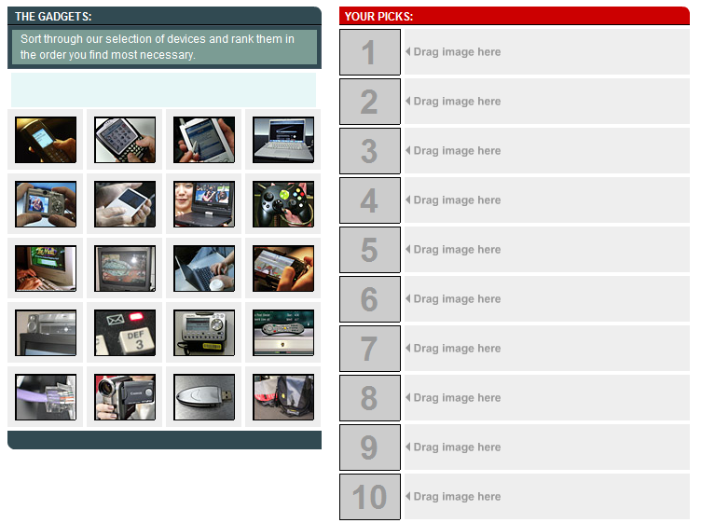
- Data Flow Diagram:
  - http://www.edrawsoft.com/images/examples/data-flow-diagrams.png
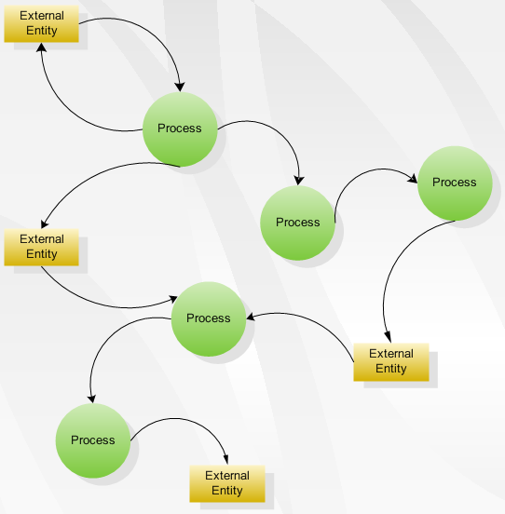
- Artifact “Cloud”:
  - http://www.ncfs.org/digital_evd_clip_image002.jpg
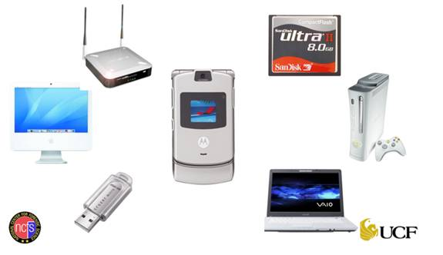
- Network Diagram:
  - http://www.gadget-spot.co.uk/prodimages/PowerlineNetwork.gif
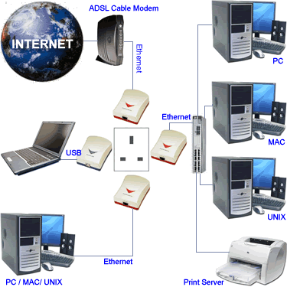
- Artifact-centric look at ecology:
  - http://www.landesk.com/Images/Products/management_suite/wheel_ldms.gif
