Social Media Evaluation of Point Spring & competitors

1. Purpose of the Study

The main goal was to understand how social media is used within the industry locally among competitors. The aim of this report is to help inform a strategy for incorporating social media into Point Spring & Driveshaft (PSD)'s digital endeavors.

The goals for this evaluation were:
- learning what accounts are already auto-created for PSD and how have they been interacted with thus far
- understand what competitors are using which social media services
- understand how close competitors are communicating through the Big 4 (Facebook, Twitter, YouTube, LinkedIn)
- learn how users react to social media pages of your competitors

2. Method

The method used was content analysis, which systematically documents and organizes a document based on certain features. These features included analyzing the type of content posted, the language used, the use of rich media, the nature of interaction with community members, frequency of posting, information included, and brand aspects to social media usage. This list has been compiled from previous research on social media and branding by the researcher. Please review Appendix A for a listing of recorded data.

Competitors of the close analysis of content were Hunter Truck Sales (HTS), Transaxle (TA), and Keystone Spring Service (KSS), however since KSS had no claimed social media pages, they were left out of the analysis. More exhaustive comparison of what competitors had which social media pages included: Superior Distributors (SD), Hovis Auto & Truck Supply (HATS), Hill International (HI), Cumberland Truck Equipment (CTE), Transedge (TE), and Truck Parts Inventory (TPI). In addition to what competitor had which service, documentable features such as likes, followers, following, views, subscribers, ratings, and checkins were also recorded for all these organizations. Appendix B contains a dictionary of common social media terms described above.

Figure 1. Shows services used by competitors. Orange represents services PSD already has pages on.

3. Findings
Many of the companies have pages automatically created as demonstrated in figure 1 by places like Facebook or Google+ and those generated by participants for Yelp and Foursquare. The majority of the use of social media (and all of PSD's) comes from these sources. It is clear that the top 3 services used by the local competitive industry is Facebook, LinkedIn, and YouTube. It should also be noted that for pages like Yelp, Foursquare, and occasionally Facebook the pages represent not just for the brand as a whole, but individual branches as well.

3.1. Metrics of use of social media by competitors
The table below documents the primary metrics—easy to document features of social media—of each site for competitors. This data shows main pages get the most overall attention (e.g., likes, followers, etc.), but that ratings and reviews (often) as well as checkins are given rather to branches. For example, on what is supposed to be the Greensburg branch of PSD a customer has left a comment on Foursquare, “Great place to get a well built transmission.....” (https://foursquare.com/v/point-spring--driveshaft/4fa97c74e4b06344ef0d7a01).

The average number of likes is 646 of Facebook, followers is 1005 on Twitter (although many of these may not be customers but other like-minded industry organizations), 586 subscribers on YouTube. These will likely not be the same individuals, but there will be a significant amount of overlap in these connections. The data also shows large standard deviations—larger than the averages themselves. This means that there is a wide amount of variance in the data and a number of organizations have many fewer or many more followers. Removing the non-claimed Facebook pages, such as PSD, CTE, TE, and KSS, the average jumps to 969 likes, but still with a lot of variance. A 2-tailed t-test comparing number of likes with whether it was claimed or not resulted in t(9)=1.757, p<0.10. This is a borderline value, but does show there is a likelihood that there is a difference between not claiming a page in terms of likes and claiming it.

Claiming a page and adding base level content should boost user interaction with page, which may lead to increase in traffic to the website.

Table 1. Metrics of use and interaction on social media for all competitors.

PSD itself has 2 likes among the main branch and all other branches (2 others, e.g., New Castle and Meadville) and 7 Facebook checkins as well as 11 Foursquare unique visitors and 121 Foursquare checkins for the various branches.

I attempted to correlate the number of likes to the number of posts (r(9)=0.4686) for the data in Table 1. This correlation value is not particularly strong yet not negligible either. This means:

An active Facebook page in general is necessary to have a strong following, but that is not the only thing one must do to gain a social media following.

There was not enough data to do the same sorts of tests for Twitter and YouTube.

3.2. Details of use of social media accounts
The follow up in-depth analysis looked at HTS for Facebook (the only page HTS adds content to) and at TA for Facebook, Twitter, YouTube, and LinkedIn. HTS made 34 Facebook wall posts as of this writing running from 4/29/14 to the present. TA made 17 Facebook wall posts, 35 tweets, and 6 videos with activity 12/14/10 to 2/2/12 for Facebook and Twitter and 9/6/13 to 3/11/14 for YouTube.

The way these two organizations set their Facebook pages up were similar. They both included a company logo. TA also included an image of their staff on the front section. The type of information provided in the About section was very similar. Contact information, product line, specialties. HTS included their mission, while TA include practical information like hours and parking situation. They both included photos on the website as well. But, HTS included many more—more than 6 times as many (e.g., 92 for HTS, 15 for TA). There was a low overall percentage of the number of photos of customers. Granted these would be hardest photos to collect, but there ought to be more than 4 total among both competitors. For TA on Twitter and YouTube, the pages were setup very similarly with the same icon being used in Twitter as in Facebook, while YouTube and LinkedIn only used the logo.

Overall, TA had 138 Facebook likes for their page, while HTS had 1541. TA also had 439 followers (and they themselves were following 529) and 106,431 YouTube views, most of which came from one video, though only 2 subscribers.

As far as the content posted, Facebook wall posts were about 160 characters long, and each posts averaged 5.99 likes. There was a very large difference between TA (avg. = 0.5, st. dev = 0.9) and HTS (avg. = 9.1, st. dev = 6.4). There was very little other interaction with viewers other than likes. No post received any comments. Finally HTS received 5 shares of their posts, while TA received none.

There was a large difference between the purpose of posting between the 2 competitors, such as company-centric content (TA 88.2%, HTS 47.1%), knowledge sharing (TA 17.6%, HTS 5.9%), entertainment (TA 0%, HTS 14.7%), and community engagement (e.g., asking questions, requesting feedback, posting contests, events, and polls) (TA 5.9%, HTS 29.4%).

On Twitter, TA was a bit less company-centric and posted company-centric content 51.4% only, knowledge sharing 28.7%, entertainment 14.3%, and community engagement 8.6%. On YouTube, TA posted half the videos as contest promotion (without much in social media interaction) and half the videos promoting the company itself.

In social media, content must be user-centered, particularly for Twitter. Users want to see updates of the company, but these media are primarily entertainment/enrichment platforms. The majority of posts should be knowledge sharing, entertainment, or community engagement. The exact mix depends on the goals of using social media.

The breakdown of media posted included 60% of the posts using at least one image by the company itself (on Facebook some links posted include an image attached by Facebook—it is easy to distinguish the two), 1.9% including a video, 29.4% having a link with no image posted by the company, and only 11.8% providing text only.

On Twitter, which is a bit more skewed toward text-based interaction, links were provided 82.8% of the time and text-only tweets occurred 5.7% of the time. Only one rich media was posted, which was a video.

There was a medium correlation between visual imagery and likes for a post: r(52)=0.5985. This means there is likely some relationship between using images in posts and positive feedback (likely also paying attention to posts in the first place as well) in Facebook.

All social media is primarily visual in nature, even the best tweets include images/videos. Text post/tweets are inherently less popular than visual posts/tweets.

The language used on the website demonstrated passive voice (used only for indirect, non-powerful language) approximately 15% of the time on Facebook. The most popular strong nouns/verbs were truck, show, service, event, location, commercial, business, customer, new, driving, thank, website, visit, used, and provides in that order.

Tweets used the same amount of passive voice approximately, and the most popular nouns/verbs were new, news, year, page, website, truckers, trucking, weekend, truck, highlighted.

Social media should use user-centered language. Use terms you want your audience to identify with your organization.

One last comment, companies need to actively pay attention and respond to what community members are posting to their social media pages. TA has not posted to their Facebook page in more than 2 years. Nonetheless, an individual made a series of wall posts on their company Facebook page saying they hired drug addicts. The following was also posted on their page at the tail end of when they were posting to their page:

“These folks don't seem to care about the small individual trucking companies. I purchased a reman trans from them 6 months ago.....3 months later the transmission failed.....yesterday my transmission failed again. I called the company and I'm still waiting to hear back regarding my warranty. They don't live up to their warranty. I'm down $12,000. plus whatever I'm missing out on loads. “

and was responded to not by TA but by another customer:

“Try out Camerota truck parts. i had a great experience with them.”

A customer (or maybe someone from their competitor) was redirecting them to a competitor on TA's Facebook page.

When adopting social media, someone always needs to be monitoring what people are saying about the company and the industry. These industry postings are perfect opportunities to make positive connections via social media, so monitoring can help prevent bad situations and lead to favorable ones. Even after one has stopped posting, the company must keep an eye what is going on your Facebook walls, YouTube comments, and tweets @ the company. Furthermore, you need to respond to participants. If someone posts something offensive, it is standard practice to delete it, but it is not wise to delete purely negative comments—you can only respond to them and try to show your hospitality and humility to other community members. But, members need to feel like the company is listening to them.

Monitoring social media is an ongoing process. Responding to, listening to, and staying active is the only way to “control” social media. A company needs to stay ahead of problems, it can't solve them.

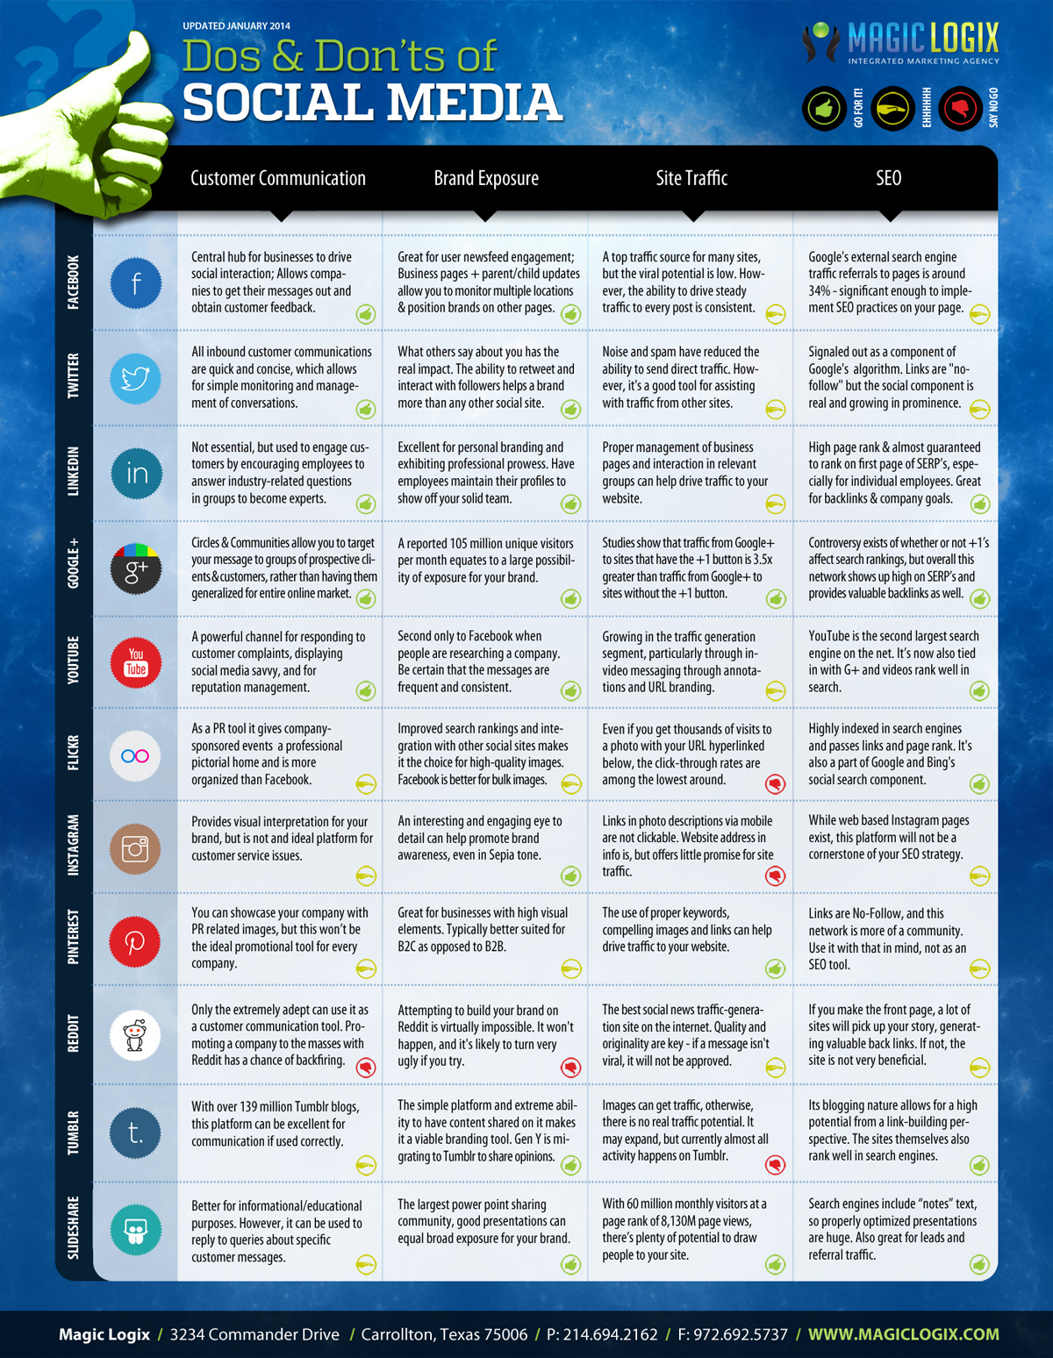
Figure 2. An infographic evaluating the various social media platforms for customer communication, brand exposure, site traffic, and SEO. This information is courtesy of Magic Logix Marketing Agency from 2012.

4. Recommendations

- Identify goals for using social media
- Define who your social media community members would be
- Develop a plan for finding relevant industry blogs, social media, and website. Contribute to those sites and find a way to develop a community of followers of your own.
- Identify platforms and connect individual goals with each platform
- Plan a consistent visual design that integrates all digital initiatives website, all social media, any email newsletters, etc
- Develop a plan for monitoring your own social media accounts, your competitors accounts, relevant industry accounts, and customer accounts (where possible)
- Develop a plan for how often you will post different types of content
- Create a list of ideas for contests, questions, events, and other interactive components to post on social media

Figure 2 demonstrates the value of various platforms according to various goals. Your future plans may want to take this into account. We can discuss these further once we address the above recommendations.

Appendix A. Data Recording Listing

- Overall
  - Main Facebook Page
    - Main Header
      - logo
      - tagline
      - pictures of employees (main header
      - pictures of customers(main header)
      - pictures of products (main header)
      - pictures of facilities (main header)
      - pictures of brand elements (main header)
    - Photos
      - pictures of employees
      - pictures of customers
      - pictures of products
      - pictures of facilities
      - pictures of brand elements
    - About Tab
      - address
      - phone number
      - hours
      - official page notification
      - website
      - email
      - history
      - product line
      - mission
      - vision
      - specialties
      - also on
      - parking
    - Language
      - strong verbs/nouns
      - passive Voice %
  - Twitter Page
    - logo
    - tagline
    - pictures of employees (main header
    - pictures of customers(main header)
    - pictures of products (main header)
    - pictures of facilities (main header)
    - pictures of employees
    - pictures of customers
    - pictures of products
    - pictures of facilities
  - YouTube Page
    - logo
    - tagline
    - pictures of employees (main header
    - pictures of customers(main header)
    - pictures of products (main header)
    - pictures of facilities (main header)
    - strong verbs/nouns
    - passive voice %
  - LinkedIn Page
    - Main Header
      - logo
      - tagline
      - pictures of employees (main header)
      - pictures of customers(main header)
      - pictures of products (main header)
      - pictures of facilities (main header)
    - Photos
      - pictures of employees
      - pictures of customers
      - pictures of products
      - pictures of facilities
    - Content
      - history
      - product line
      - mission
      - vision
      - specialties
      - size
      - industry
      - founded
    - Language
      - strong verbs/nouns
      - passive voice %
- Individual Post/Tweets/Videos
  - Facebook Posts
    - Organization
    - Post Date
    - Topic
      - Company Updates
      - Press Release
      - Industry News
      - Knowledge Sharing
      - Entertainment (in-context)
      - Entertainment (out-of-context)
      - Question
      - Product Promotion
      - Brand Promotion
      - Poll
      - Event
      - Request Feedback
      - Contest
      - Employment
    - Share Count
    - Media Shared?
      - Text Only
      - Link
      - Image
      - Poll
      - Video
    - Likes
    - Character Count
    - Comment Count
    - Positive Comment Count
    - Negative Comment Count
    - Junk Comment Count
    - Positive Comment Competitor Count
    - Negative Comment Competitor Count
    - Response by Brand Count
    - Character Count of Brand Reply
    - Strong Verbs/Nouns
    - Passive Voice %
    - Strong Image/Text connection
  - Twitter Page
    - Organization
    - Tweet Date
    - Topic
    - Time Delay of Reply (@) post/ Retweet (-99 if not one of those categories)
    - Media Shared?
    - Hashtags
    - Favorite
    - Retweets
    - Replies
  - YouTube Page
    - Organization
    - Date
    - Topic
    - Views
    - Number of Employees
    - Number of Customer
    - Number of Products
    - Number of Facilities
    - Links to Other Videos
    - Links to Other Social Media
    - Links to Non-Social Media
    - Time (s)
    - Character Count of Description
    - Positive Comment Count
    - Negative Comment Count
    - Positive Comment Competitor Count
    - Negative Comment Competitor Count
    - Response by Brand Count
    - Character Count of Brand Reply
    - Strong Verbs/Nouns
    - Passive Voice %
Appendix B. Social Media Dictionary

- Likes – Anyone with a Facebook account (user or even other organizations) can show their support by clicking a thumbs up icon. This can be for a post, webpage, or any other Facebook connected content.
- Talking About – In Facebook, the software monitors how often accounts mention particular company names in their own wall posts. This is then reported back on the company's main brand page. This is a quantitative metric that could be akin to social media buzz/trends.
- Shares – When a Facebook account shares an individual post or page with their group of connections. On Twitter, these are known as Retweets.
- Checkin – For websites like Facebook and Foursquare, account holders can use their mobile devices to show they physically visited a location.
- Connections – These are people and organizations who have made some sort of connection through social media. On Facebook: Friends, On Twitter where connections are one way: Followers (for those you have connected with you), Following (for those who you have connected with), On LinkedIn: Followers, Connections. On YouTube: Subscribers (one way only).
- Hashtag – This is a categorizing term, delimited by #. This is a way accounts on Twitter, specifically, but occasionally in other social media as well, can show what their tag relates to or join a larger discussion.
- Views – In YouTube, how many people viewed the video.

